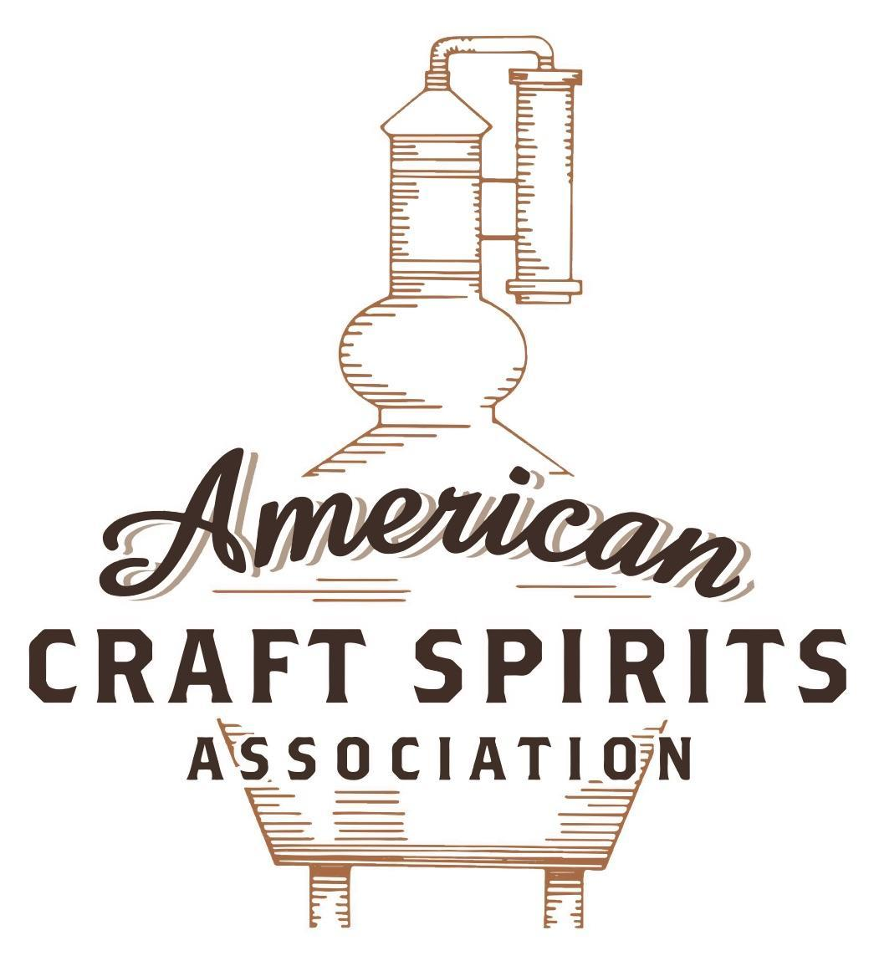
Spirits DtC Shipping Guide

This guide summarizes the direct-to-consumer shipping rules for distilleries in all 50 states and D.C. and also addresses the measures state governments have taken to ease delivery and shipping restrictions during the COVID-19 pandemic.

DtC Quick Guide Comparison

Out-of-State Distilleries  Can Ship Into State? |  |  |  | In-State Distilleries  Can Ship Within State?
State | Yes | No |  | State | Yes | No
AL |  | X |  | AL |  | X
AK | X |  |  | AK | X
AZ | X |  |  | AZ | X
AR |  | X |  | AR |  | X
CA |  | X* |  | CA |  | X*
CO |  | X |  | CO |  | X
CT |  | X* |  | CT |  | X
DE |  | X |  | DE |  | X
DC | X |  |  | DC | X
FL |  | X |  | FL |  | X
GA |  | X |  | GA |  | X
HI |  | X* |  | HI |  | ?*
ID |  | X |  | ID |  | X
IL |  | X* |  | IL |  | X*
IN |  | X |  | IN |  | X
IA |  | X* |  | IA |  | X*
KS |  | X |  | KS |  | X
KY | X |  |  | KY | X
LA |  | X |  | LA |  | X
ME |  | X* |  | ME |  | X*
MD |  | X |  | MD |  | X
MA |  | X |  | MA |  | X
MI |  | X |  | MI |  | X
MN |  | X |  | MN |  | X
MS |  | X |  | MS |  | X
MO |  | X |  | MO |  | X
MT |  | X |  | MT |  | X
NE | X |  |  | NE | X
NV |  | X* |  | NV |  | X
NH | X |  |  | NH |  | X*
NJ |  | X* |  | NJ |  | X*
NM |  | X |  | NM |  | X
NY |  | X* |  | NY |  | X*
NC |  | X |  | NC |  | X
ND | X |  |  | ND | X
OH |  | X |  | OH |  | X
OK |  | X |  | OK |  | X
OR |  | X |  | OR | X
PA |  | X* |  | PA |  | X
RI |  | X* |  | RI |  | X
SC |  | X |  | SC |  | X
SD |  | X |  | SD |  | X
TN |  | X |  | TN |  | X
TX |  | X |  | TX |  | X
UT |  | X |  | UT |  | X
VT |  | X |  | VT |  | X
VA |  | X |  | VA |  | X
WA |  | X* |  | WA | X
WV |  | X* |  | WV |  | X*

WI |  | X |  | WI |  | X
WY |  | X |  | WY |  | X

Notes:
*CA: If passed and signed into law, Senate Bill 620 would allow licensed distilled spirits producers in states other than California and licensed distilled spirits manufacturers or craft distillers in California who obtain distilled spirits direct shipper permits to ship directly to consumers in California
*CT: Consumers with appropriate permit may receive alcohol shipments
*HI: Consumers with appropriate permit may receive alcohol shipments; If passed and signed into law, Senate Bill 65 would allow licensed distilled spirits manufacturers in Hawaii and in states other than Hawaii who obtain direct shipper permits to ship directly to consumers in Hawaii
*IL: If passed and signed into law, Senate Bill 0532 would allow licensed distilled spirits producers in Illinois and in states other than Illinois who obtain distillery shippers’ licenses to ship directly to consumers in Illinois
*IA: If passed and signed into law, House File 639 would allow native distilled spirits manufacturers in Iowa and in states other than Iowa who obtain direct shipper permits to ship directly to consumers in Iowa and to consumers in states other than Iowa
*ME: If passed and signed into law, Legislative Document 1358 would allow distilleries outside of Maine with current manufacturer licenses and distilleries licensed in Maine who obtain spirits direct shipper licenses to ship directly to consumers in Maine
*NJ: (1) If passed and signed into law, Assembly Bill 3167 would allow a craft distillery licensees to ship no more than 9 liters of distilled spirits to a consumer in New Jersey; (2) If passed and signed into law, Senate Bill 3020 would allow craft distillery licensees in New Jersey or in states other than New Jersey to ship no more than 20 liters of distilled spirits to a consumer in New Jersey via common carrier
*NV: Licensed individuals can import one gallon per month of spirits for personal use and the out-of-state supplier must pay excise tax
*NH: If passed and signed into law, Senate Bill 125 would allow licensed liquor manufacturers who obtain direct to consumer shipping permits from the commission to ship directly to consumers in New Hampshire
*NY: Consumer may import up to 90L of liquor per year for personal use without a license; If passed and signed into law, Assembly Bill 3275 would allow licensed liquor manufacturers in states other than New York and licensed distillers and farm distillers in New York to ship no more than thirty-six cases (no more than nine liters per case) of liquor to consumers in New York
*PA: Consumer may place a special liquor order and distiller must ship to a PLCB-operated store
*RI: Distiller can only ship to customer if order was personally placed by customer at distiller's premises
*WA: If passed and signed into law, House Bill 1432 would allow licensed spirits manufacturers in states other than Washington to ship spirits to consumers in Washington
*WV: Distilleries, mini-distilleries, or micro-distilleries licensed in West Virginia or a state other than West Virginia who obtain private direct shipper licenses to ship to a consumer in West Virginia, however the shipments must be made to a retail liquor outlet

CALIFORNIA
Shipment outbound – California’s law is silent on outbound shipments. Although the rules of construction do not state that any action not expressly authorized is prohibited, the rules of construction are drafted broadly so that any provision may be interpreted to help achieve the safety, welfare, health, peace, and morals of Californians (CA BPC § 23001).
Shipment inbound – No (CA BPC § 23661).
Shipment intrastate – No, a licensed craft distiller may sell only up to the equivalent of 2.25 liters in any combination of prepackaged containers per day per consumer of distilled spirits manufactured or produced by the licensee at its premises to a consumer (CA BPC § 23504).
COVID Measures – Normally, Type 74 (craft distiller) licensees may not deliver alcoholic beverages to consumers away from the licensed premises, but enforcement of the delivery provision is temporarily suspended. During the pandemic, payments for products can also be made at the time of delivery. Licensees must still, however, comply with the 2.25 liter per consumer per day limit. It is up to the delivery company as to whether they will deliver alcohol. The licensee is ultimately responsible for ensuring that the delivery person does not deliver to a minor. The provision allowing alcoholic beverage deliveries to consumers will temporarily remain in place until December 31, 2021.
First Notice of Regulatory Relief Link:
https://www.abc.ca.gov/notice-of-regulatory-relief/
Modification of COVID-19 Relief Regarding On-Premises Meal Requirements Link: https://www.abc.ca.gov/modification-of-covid-19-relief-regarding-on-premises-meal-requirements/
Eighth Notice of Regulatory Relief Link:
https://www.abc.ca.gov/eighth-notice-of-regulatory-relief/

Citation (shipment)
Cal. Business & Professions Code
§ 23001. Purposes of division; Construction
This division is an exercise of the police powers of the State for the protection of the safety, welfare, health, peace, and morals of the people of the State, to eliminate the evils of unlicensed and unlawful manufacture, selling, and disposing of alcoholic beverages, and to promote temperance in the use and consumption of alcoholic beverages. It is hereby declared that the subject matter of this division involves in the highest degree the economic, social, and moral well–being and the safety of the State and of all its people. All provisions of this division shall be liberally construed for the accomplishment of these purposes.
§ 23504. Sale of distilled spirits during instructional tastings.
Notwithstanding any other provision, a licensed craft distiller may sell up to the equivalent of 2.25 liters in any combination of prepackaged containers per day per consumer of distilled spirits manufactured or produced by the licensee at its premises to a consumer.
§ 23661. Who may import; Application of chapter and section; Shipment by member of armed forces. (a) Except as otherwise provided in this section, alcoholic beverages shall be brought into this state from without this state for delivery or use within the state only by common carriers and only when the alcoholic beverages are consigned to a licensed importer, and only when consigned to the premises of the licensed importer or to a licensed importer or customs broker at the premises of a public warehouse licensed under this division.
(f) A manufacturer of distilled spirits shall transport such distilled spirits into this state in motor vehicles owned by or leased to the manufacturer, and operated by employees of the manufacturer, only if all of the following apply:
(1) The distilled spirits are transported into this state from a place of manufacture within the United States.
(2) The manufacturer holds a California distilled spirits manufacturer’s license.
(3) Delivery is made to the licensed premises of such distilled spirits manufacturer.

Link to CA ABC Act: https://www.abc.ca.gov/wp-content/uploads/2020_CA_ABC_Act.pdf

The American Craft Spirits Association (ACSA) is working diligently to give our members and industry partners relevant, current updates on statutes and regulations impacting production, sale and distribution of spirits. With the declaration of the novel coronavirus (COVID-19) in early 2020, many states have issued temporary policy changes or longer-term modernization of alcohol beverage laws. State statutes, regulations created by the state alcohol regulatory authority, as well as any other relevant guidance provided by such authorities (such as advisories, opinions, bulletins, etc.) were reviewed in creation of this document. No city or county ordinances were reviewed. Distillers should be aware that even in states where direct shipping is permissible, always remember to avoid shipping to dry counties. Please consult with your state guild or alcohol beverage authority for the most up-to-date information. This content is intended for educational and informational purposes only. ACSA's pro bono law firm of Malkin Law P.A. provided the core content found in this comprehensive overview of the spirits distribution after COVID-19. It was completed in August 2021 and will be updated regularly. If you have updates you would like to provide, please send to legislation@americancraftspirits.org or directly to the law firm at: ryan@malkin.law / malkin.law. Thank you.
S.B. 620 is pending in California that would authorize a licensed distilled spirits producer in any other state who obtains a distilled spirits direct shipper permit to sell and ship distilled spirits directly to a resident of California who is at least 21 years of age for the resident’s personal use. The bill was introduced on February 18, 2021 and is in committee. Link: https://leginfo.legislature.ca.gov/faces/billTextClient.xhtml?bill_id=202120220SB620
S.B. 620 is pending in California that would authorize a licensed distilled spirits manufacturer or craft distiller who obtains a distilled spirits direct shipper permit to sell and ship distilled spirits directly to a resident of California who is at least 21 years of age for the resident’s personal use. The bill was introduced on February 18, 2021 and is in committee. Link: https://leginfo.legislature.ca.gov/faces/billTextClient.xhtml?bill_id=202120220SB620

